Appendix C
Facility Illustration

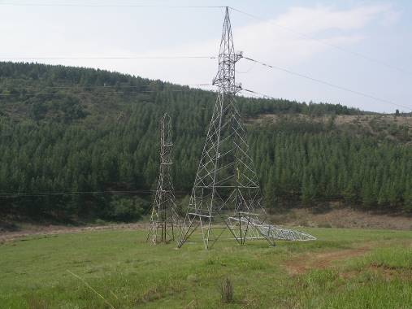
Fig 1 Typical turning tower

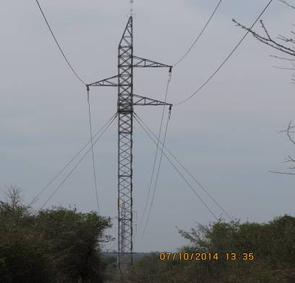

Fig 2 Typical strain/middle tower

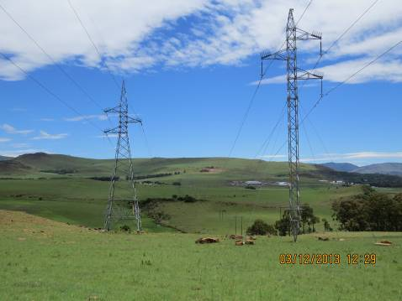
Fig 3 Typical strain/middle tower

